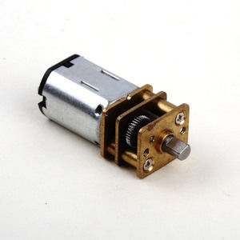

#### 12mm DC gear motor series

**SPECIFICATIONS:**

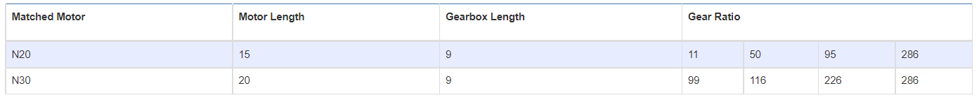

**SUBMODELS:**

*The following are common submodels for the LDO-12FN series.*

